QUALITIES OF LIGHT

Diffused light is soft and fuzzy.
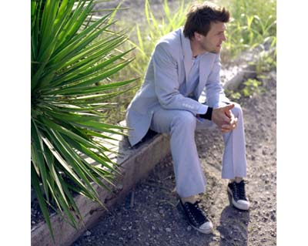
Gayle Brooker
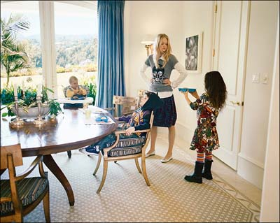
Tierney Gearon

Harsh light is sharp and contrasty.
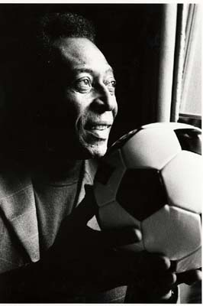
Ralph Gibson
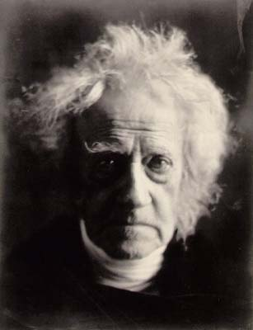
Julia Margaret Cameron

Light can spill through windows and doorways.
Claudio Cambon
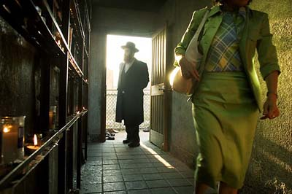
Carolyn Drake
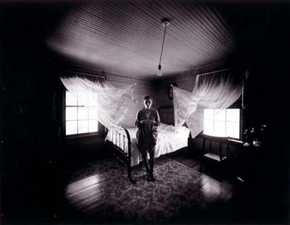
Emmet Gowin
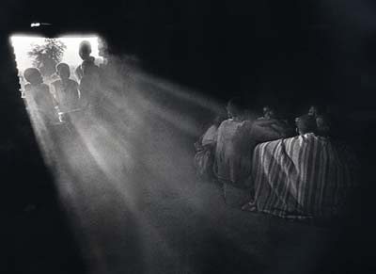
Sabastiao Salgado

Light can create a mood or emotion.
Gayle Brooker
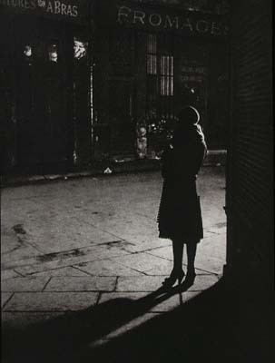
Brassai
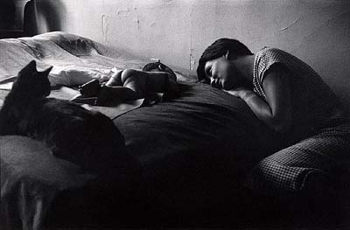
Elliott Erwitt

