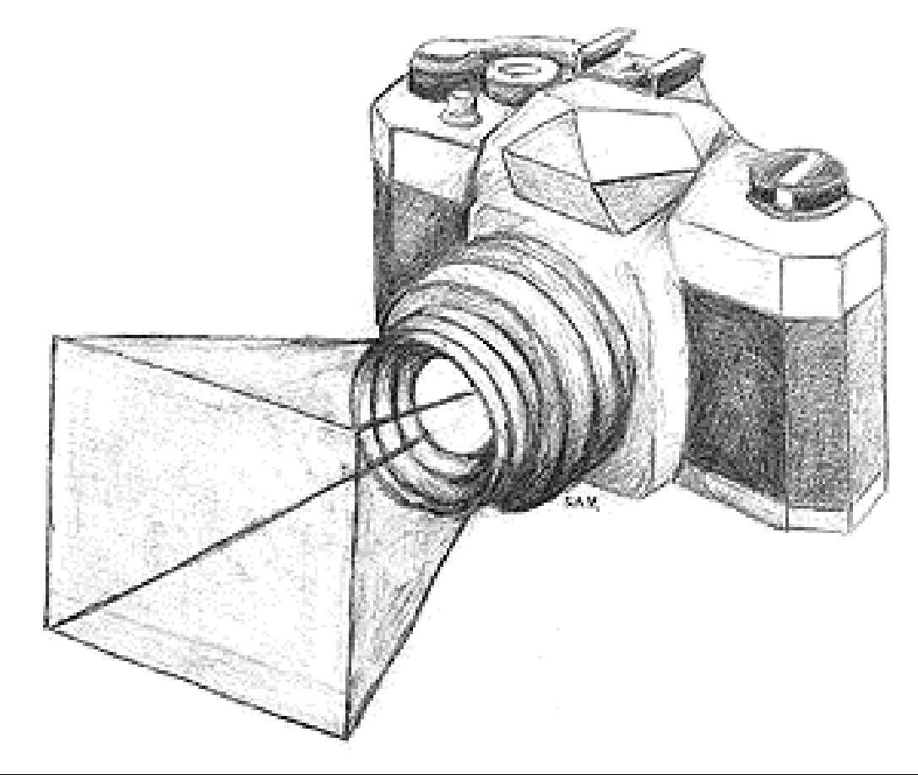

Photography Information Booklet

CHAPTER 1

HISTORY

The camera was invented 300 years before the first photograph was taken. DaVinci used one at the turn of the fifteenth century. In 1558 there was a reference to a camera obscure. Today we call this a pinhole camera. A pinhole camera is a closed box with a very small hole that allows the image to come through and project itself onto the side of the box opposite the hole. Years later a lens replaced the hole. The lens caused the picture to be sharper.

A typical pin hole camera  Film is taped to the bottom of a large coffee can. The open end is covered with foil that has been pierced with a needle. A flap covers the hole. All this is done in total darkness. An exposure is made by lifting the flap for about a minute, depending on the size of the hole. | 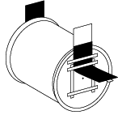

In 1826 the first known photograph was taken. It was a fuzzy, grainy picture of the view from the window of Nive’phore Nie’ce, a French inventor. Nie’ce had found a way to fix (or make permanent) the image which other inventors previously had been unable to do. The picture, however, was on a metal plate and could not be reproduced. Each photograph was one of kind. There were no methods of duplication, if many copies were needed. It also took 10 to 45 minutes to make exposures, that is, to allow enough light to strike the plate to have the necessary chemical reaction. | 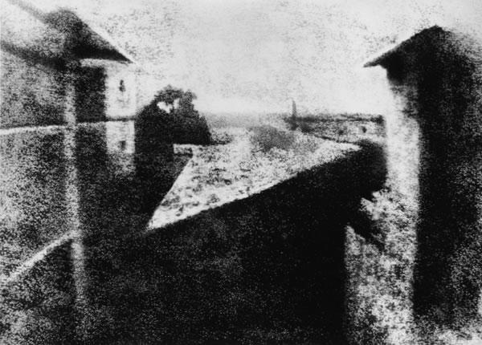

In 1839 a negative/positive system was discovered which allowed the photographer to first shoot a negative. The negative could then be used to make multiple copies that were positive.

Negative Image | Positive Image
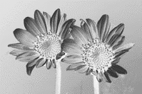 | 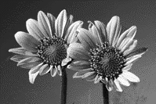

In 1888 George Eastman introduced a small box camera. He had previously been working on coating rolls of paper with emulsion (light sensitive particles). He combined these two products into a package camera that was loaded with film at the factory. The buyer could take 100 pictures before sending the entire camera back to the factory.

CHAPTER 2
PHOTOGRAPHIC CONCEPTS

If you compare the camera with the human eye, you will find many similarities. Your eye admits light through the cornea and the pupil, with a variable iris to adjust brightness; it uses tissue lens to give a sharp image and a light sensitive area, the retina to receive it. The camera admits light through the lens aperture, which is adjusted by a variable diaphragm (or iris); it uses a glass lens, and a light –sensitive film. Both lenses can be focused for different distances and both form miniature upside-down images of the scene.

Eye | Camera | Function
Lens-  - Soft clear membrane that focuses images by changing its shape | Lens-  - Precise ground glass  - Sometimes arranged in groups | - Collects light from the scene  - Focuses the image to make it clear and sharp  - Turns the image to make it clear and sharp
Iris-  - Opaque membrane that varies the size of opening | Aperture-  - A circle of thin metal pieces that can be moved to make the hole different sizes | - An opening to let light in  - Affects the depth of field
Retina-  - A light sensitive membrane that picks up light and sends a message to the brain | Film-  - An acetate base strip treated with light sensitive chemicals | - Records the scene in the form of an image

The similarities end there. You cannot assume the camera sees as you do. There are basic differences between seeing and photographing which you should understand – otherwise your pictures may look very different from the scene you remember. With practice you can learn to anticipate what the camera sees.

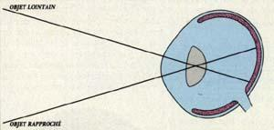

Human vision is controlled partly by the eye and partly by the brain. This arrangement gives you selective vision. You can notice important images on the retina and disregard others. For example the words you are now reading appear sharp and clear, whereas the words surrounding them are less distinct. Selective vision eliminated distracting elements. The camera cannot do this – it records what is there, with objects at the same distance all appearing equally clear. So photography often records too much (the unimportant along with the important. You must get used to scanning your viewfinder frame thoroughly for unwanted elements, particularly around the edges. You can usually exclude them by changing you viewpoint or framing.

The eye seldom presents you with an out-of-focus image. If you glance up from these notes to look at another object across the room, the detail will look equally sharp. Your eyes have refocused from the new distance automatically. Only if you hold your notes up in line with that other object, and try to see both at once, will you discover that focusing on one causes the other to appear fuzzy. You can alter the focus of a camera lens in the same way. But if you take a picture with, say the notes in focus and the other object out-of-focus, this situation is fixed within the photograph. You cannot then move your eye from one to the other to see both the scene in focus when you shoot the picture. This selective focus is useful for directing attention in you pictures.

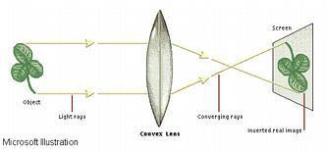

The camera reduces the three-dimensional world to a two-dimensional image. The picture formed at the back of your eye is also two-dimensional, but you see in three dimensions. This is partly because you have two eyes and so you see everything from two slightly different viewpoints. Look through your left eye only, and line up a close object with one much further away. Without moving your head, now look through your right eye only – the relationship of the two objects will change. Your brain interprets the differences to judge space, distance and depth. In a two-dimensional photograph you have to communicate depth by overlapping near and far objects and by choosing lighting that shows three-dimensional forms.

CHAPTER 3
THE SCIENCE OF LIGHT

Light is the medium photographers use to create their pictures. Just as artists experiment with the mediums they use, (oil paints, charcoal, ink clay, etc.) photographers must have a basic understanding of light and the affects it has on their creations.

Light is the source of the colors and hues recognized by the human eye. Light travels outward from a source in straight paths called waves (rays). Pure whit light is a mixture of all the visible colors. This may be proven by shining pure white light through a prism. The rays that exit the prism are separated into a rainbow of colors ranging from red to violet. This group of colors is known as the visible spectrum.

The spectrum

Light is responsible for allowing us to see when white light strikes a surface some colors of the spectrum are reflected and others are absorbed. The colors our eyes recognize are those oft the reflected rays. A red apple for example, appears red because the surface of the apple reflects red rays AND absorbs all of the other rays that strike its surface. Black surfaces absorb all parts of the spectrum while white surfaces reflect all the rays that strike them. Black and white are not colors, black is the absences of light and white is a mixture of all spectrum colors. Objects become visible only when light rays are reflected and absorbed.

QUALITIES OF LIGHT
- Intensity: The brightness or dimness of light reaching your subject. It is what your light meter measures. If you make meter readings carefully, the intensity of the light shouldn’t directly affect the brightness or dimness of the final photograph because you adjust shutter speed and aperture to match light levels.
- Degree of Diffusion: Light can be very sharp and concentrated, or at the other extreme, it can be very soft and diffused. Sharp light usually produces harsh, well-defined shadows. It generally comes from a single point, such as a flash unit or the sun on a cloudless sky. Diffuse light, on the other hand, gives hazy, ill-defined shadows or no shadows of all. Diffused light emanates form a large light source, like the sun filtered through clouds on an overcast day.
- Source of Light: The source of light can be direct or reflected. Direct light shines form the source to the subject photographed. Reflected light shines form the source and is directed by a surface toward the object.
- Direction: The angle that the light strikes your subject affects the way texture and shapes are depicted in the photograph. A sidelight will rake across the subject and enhance the texture. Front lights minimize texture and creates few shadows. As a result, the subject usually appears rather flat. Backlight throws shadows on the front of the subject. Light that comes from above looks “natural”.

Light can determine if your picture looks two of three dimensional. An egg is a good example of this.
Two Dimensional Three Dimensional
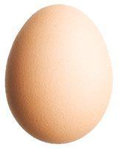

CHAPTER 4
THE CAMERA

The camera is the tool that a photographer uses to create a finished product. Photographers are only as good as their ability to use their tools.

The cameras function is to record the image. It has the ability to control the amount of light passing through, to focus and to record the image.

There are many types of photographic cameras. They all have certain things in common. They are light tight boxes that means that no light can get inside unless we allow it to. They all have a place for film, and they all have a device for limiting the mount of light that enters.

A basic photographic camera is a light tight box, with a place for film and an opening with a shutter to allow only the proper amount of light inside.

Basic Camera Parts
- Light Proof Box: A box that keeps all light out and serves as a frame to hold the other parts
- Lens: Collects the light reflected from a subject and forms an image on the film in the back of the camera. It may be either simple factory set lens for normal picture taking distances (as on simple cameras) or of the focusing type (adjustable for distances as on adjustable cameras).
- Lens Opening or Aperture: A hole (represented by a value) that controls the amount of light reaching the film. This is also factory set on simple cameras and adjustable on adjustable cameras.
- Shutter: Controls the time light is allowed to reach the film. It keeps light out until a picture is made. Simple cameras may have asset of shutter speeds and adjustable cameras usually have a re-angle of shutter speeds (usually in fractions of a second).
- Film Advance Lever: Advances the film to the next exposure. On simple cameras, a window on the back tells when to stop winding. Adjustable cameras usually stop automatically when the new frame is in position.
- Shutter Release Button: Triggers the shutter to open and close
- View Finder: Used to aim the camera and show what will be in the picture
- Focusing: A control that is used to form the sharpest possible image on the film.

These are all the shared basic elements of a camera. There are, however, many different styles of cameras and these can be divided into certain groups.

Styles of Cameras
- The simple box camera  These cameras have few controls. They take pictures only under certain conditions. They are prefocused for a certain range, and have only one shutter speed. Their simple viewing system consists of looking through the camera peephole window. The lenses in these cameras are usually low quality and in most cases, made of plastic. | 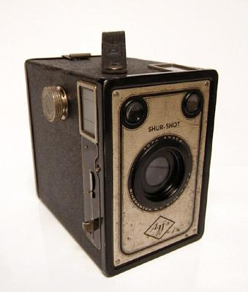
- Rangefinder camera  These cameras vary from low quality to some of the best cameras available. They share one standard feature, the focusing and viewing system. The photographer looks through a viewer, which is near the cameras lens, and sees two images. One image is superimposed on the other. As they are focused, the two images line up and become one. These cameras, because of there simple design, are smaller and often very rugged. They are quieter than a single lens reflex camera because of their simple design. A drawback of this type of camera is parallax, which means that you see the scene being photographed from a slightly different angle than the lens that takes the picture. | 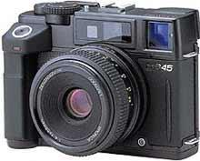  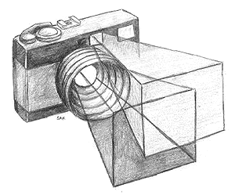  A Parallax error, what  You see in not what you  Take a picture of.
- Single lens reflex (SLR)  This is the most popular of all cameras. The biggest advantage is you see the scene begin photographed through the same lens that is used to expose the film. These cameras use a mirror system to see the scene. They are often heavy, expensive, and noisy. | 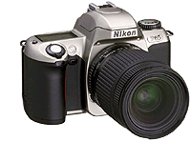
- The twin lens reflex  There are two lenses, one above the other, in this camera. The top one is for viewing and the bottom for exposing the film. The advantages here are a quiet camera, which in most instances produces larger than normal negatives. Their price is usually much lower than a similar quality slr. The camera is usually held at waist level, and the image appears on a ground glass focussing screen at the top. | 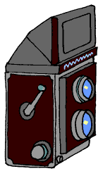
- View Cameras  This camera is unique in design and purpose. The camera has a lens on a board that can turn and tilt. Behind this is a bellows, which is flexible and allows the lens board to move back and forth. The back of the camera has a ground glass for focusing and spring clips to keep the film holder tightly in place. The back of the chamber also turns and tilts and slides back and forth. All of these parts are situated on a metal tube or rail, which allows the front and back to slide back and forth for focusing. | 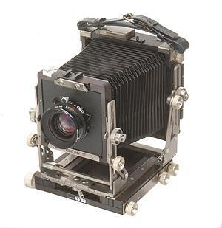
- Instant Camera  They use special film that self develops a few seconds or minutes after exposure. Both Kodak and Polaroid have developed instant cameras. The obvious advantage of an instant camera is that you can have instant photographs but the main disadvantage of is the film tend to be quite expensive, and there is no negative produced. | 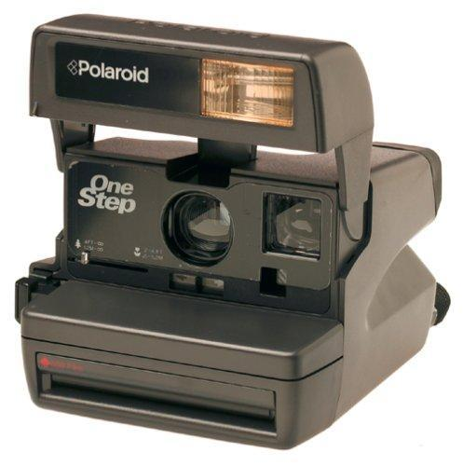

CHAPTER 5
THE SINGLE LENS REFLEX CAMERA

Parts of a Single Lens Reflex Camera
Even though other cameras are available, we will concentrate primarily on the manual 35mm single lens reflex camera. The manual SLR will be discussed in detail for several reasons. The film is fairly inexpensive and yet large enough that professional quality work can be done with it.

What is a manual 35 mm single lens reflex? Looking at it word by word: The 35mm refers to the film size. The manual means that you have to make adjustments by hand for different kinds of light. On automatic cameras, these adjustments are made by the camera itself. Single lens means that both the viewing and picture taking are done with the same single lens. Reflex mans that the image you see in the viewfinder is made up of reflected light.

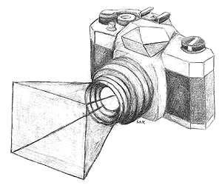 | 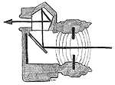

ANATOMY OF THE SLR

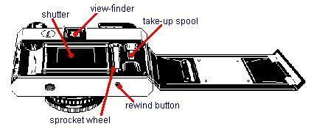

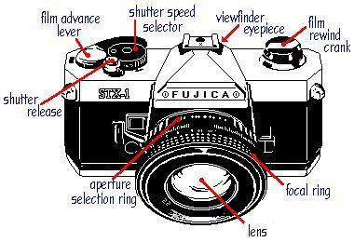

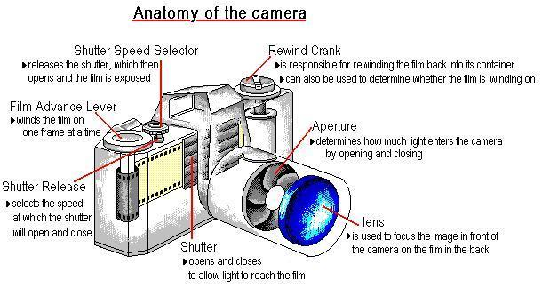

SLR LENS DISPLAY
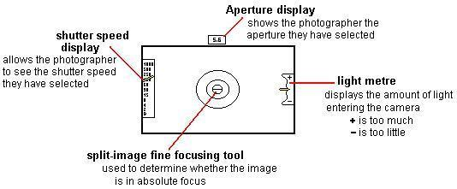

THE LENS: FOCUSING
The lens is a glass plate situated between the film and object about to be photographed. Its purpose is to focus the image onto the film. The Photographer focus and image by using the focusing ring and the "split image focusing tool" (see display).

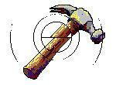 |  | 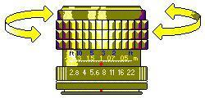

- Even though an image may appear in focus, the split circle will reveal if the image is even slightly out of focus. | - The photographer can achieve a sharper focus by turning the focusing ring at the end of the lens | - Once the lines of the image match perfectly, the sharpest focus has been achieved.

EXPOSING THE FILM

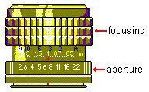 | The Lens also contains the APERTURE. The aperture is a hole in the lens of the camera that controls HOW MUCH light enters the camera by opening or closing. The smaller the hole the less light enters the camera, and conversely the larger the hole the more light enters the camera.

An aperture reading is recorded with an "f" in front and the difference between apertures are "f-stops". Each f-stop halves or doubles the amount of light entering the camera. For example: f-11 allows ½ of the light of f-8, but double that of f-16.

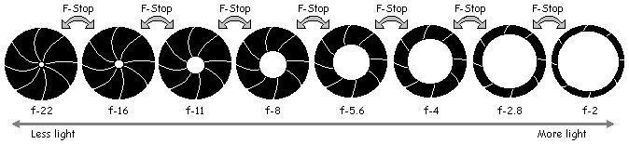

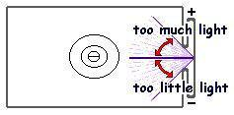 | The Photographer watches the light meter inside the camera as the aperture is adjusted, so that the correct amount of light enters the camera

SHUTTER SPEED (EXPOSURE TIME)

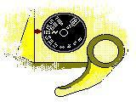 | The increase or decrease of the aperture allowing light to enter the camera must be compensated for by the shutter speed. The various shutter speeds are recorded on a dial on the top of the camera called the Shutter Speed Selector and refer to fractions of a second.

Like the aperture, the shutter speed also works in stops that allow half or double the amount of light onto the photographic film. The shutter speed controls HOW LONG the light can effect the film inside the camera by opening and closing at different speeds. The faster the shutter speed the less light will affect the film.

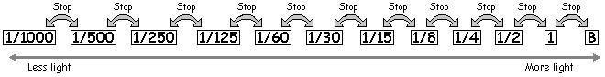

CHAPTER 6

THE PROPERTIES OF FILM
The composition of film:

In this chapter we will look at film and its light sensitive properties. The film is used to produce a negative image.

A strip of black and white film is made of several layers. The emulsion layer is here the image is formed. This layer is generally a gelatine-like substance containing crystals of silver bromide ore silver halides. The crystals are sensitive to light. When light strikes the crystals, a chemical change takes place. During the film’s development, the crystals change to silver, and clumps of the silver form the negative image. The emulsion layer adheres to the layer of flexible backing, or base, usually made of acetate. The base is covered with an antihalation coating. This coating prevents light from reflection back through the base of the film and causing unwanted exposure.

A clear gelatine topcoat holds to protect the sensitive emulsion from abrasives. Light-sensitive silver bromide or halides in the emulsion layer are either fine or thinly coated (slow film) or are relatively coarse and thickly coated (fast film). The emulsion layer is supported by a plastic or acetate base. Beneath it is another gelatine layer which prevents curling and contains an antihalation coating that prevents any light reflecting back into the upper layers

The Sensitivity of film

Film comes in a variety of film speeds; the film speed indicates a film’s sensitivity to light. Some films are more sensitive to light than others, sensitive films are called fast films and less sensitive films are called slow films. The film speed is indicated on the film:
ISO Is the International Standards Organization. This is a standard so that all films marked with the same number have the same sensitivity.

Example:
Fast films are rated with high numbers and slow films are rated with low numbers. An ISO 400 film is twice as fast as on ISO 200 film. An ISO 200 film is twice as fast as an ISO 100 film.

The film speed is determined by the size of the light sensitive material found on the film, which is known as silver bromide ore silver halides.

125 ISO  - Imagine the amount pebbles needed to fill a cup if the pebbles are small as opposed to larger stones. The cup with the small pebbles would have more weight. The silver bromide is similar on slow film. The particles of silver are smaller therefore there is more silver which need more light to expose the film. | 400 ISO  - Fast film has bigger particles of silver bromide therefore there is less total silver bromide on the film. Less light is needed to expose the silver bromide. This film is faster because the amount of time that is exposed to light is smaller.

Once the film is exposed, the silver bromide or silver halides become silver oxides. Once the film has been exposed it must go through a developing process to destroy any of the remaining light sensitive particles.

CHAPTER 7

THE PROPERTIES OF Photographic Paper

To make a positive print from a negative, the first thing you need is photographic paper. There are two basic kinds of paper: Resin-coated paper and fibre-based paper.

All papers are light sensitive and like film, have several layers.

- The gelatine super coating protects the emulsion from scratches.
- Some of the light sensitive emulsion is exposed to light and the silver halide crystals are converted to metallic silver atoms to make a latent image. The image is made permanent when developing
- The paper base is the support for the other layers
- The two resin layers protect the paper from chemicals when developing. The resin is a plastic and is absent on some paper.

Photographic paper has different finishes on it. You can purchase paper ranging from glossy (shiny) to mat (dull).

CHAPTER 8

THE DARK ROOM

The darkroom must be a light –tight room that is used for handling, processing and printing light sensitive materials in darkness or under safe lighting. The room must have sufficient ventilation for long periods of work. Ideally the room should be divided into “wet “ and “dry” areas. This not only reduces mistakes, but since water and electrical equipment are being used close to each other under dark or dim light conditions, it is also safer. The enlarger, printing equipment and printer paper should be kept on the “dry “ side of the room. The supply of water, sink, processing chemicals and equipment should be kept on the “wet” side.

FILM AND PAPER PROCESSING

Black and white film
- Developer  - Use D-76 developer  - Mix 1:1 (200ml water & 200ml developer)  - Agitate every 30 seconds  - Do not save after use  - Water wash: Fill and empty the developing tank four (4) times | ASA 125=  7 minutes  ASA 400=  9 minutes
- Stop Bath  - Use full strength  - Agitate every 30 seconds  - Save after use  - Water wash: Fill and empty the developing tank four (4) times | 1 minute
- Fixer  - Use full strength  - Agitate every 30 seconds  - Save after use  - Water wash: fill and empty the developing tank four (4) times | 5 minutes
- Hypo-Eliminator  - Mix 1:4 (75ml hypo to 300ml water)  - Do not save after use | 3 minutes
- Water Wash  - Use running water with the top off the developing tank | 5 minutes

Black and white Paper
1.Developer  a. Use dektol  - Mix 1:2 (one part developer to one part water, 200ml developer: 400ml water)  - Agitate developer by tipping the corner of the tray periodically  - Do not save after use | 11/2 -2 minutes
2. Stop Bath  - Use full strength  - Agitate tray periodically when paper is in chemical  - Save after use. | 2 minutes
3. Fixer  - Use full strength  - Agitate tray periodically  - Save after use | 5 minutes
4. Hypo-Eliminator  - Mix 1:4 (one part hypo to four parts of water, 150ml hypo: 600ml water)  - Agitate periodically  - Do not save after use | 3 minutes
5. Water Wash  a. Let prints soak in running water | 10 minute
6. Hang to dry  a. Make sure your prints are not touching | 20 to 30 minutes

CHAPTER 10
DARKROOM EQUIPMENT

