LIGHT DEFINES OBJECTS
Light can define the edges, folds, and textures of objects.

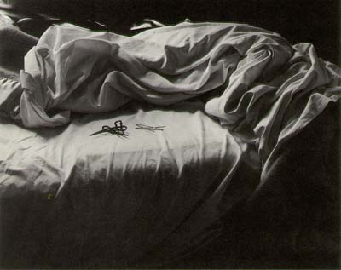
Imogen Cunningham

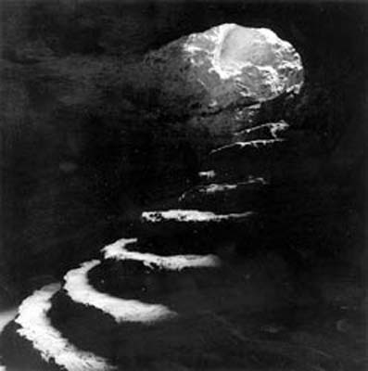
Sally Gall

Todd Hido

