LIGHT AS FOCAL POINT
Light can draw attention to a certain part of the composition.

Bob Bowen

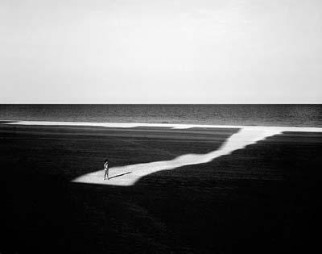
Mark Surloff

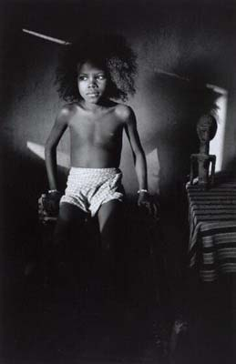
Francoise Hunguier

Anoushka Fitz

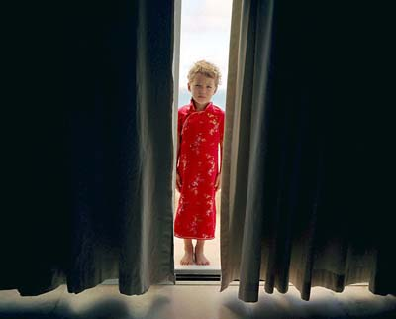
Tierney Gearon

