LIGHT AND VISUAL WEIGHT
Light can have visual weight and become objects.

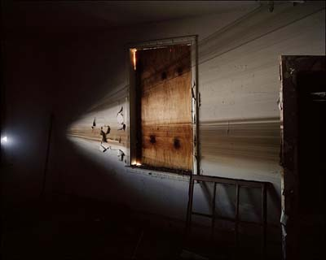
Jefferey Stockbridge

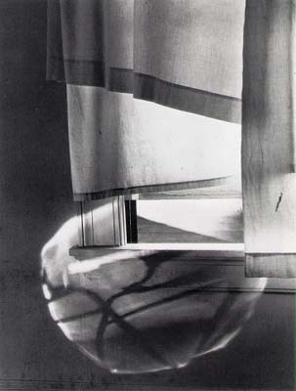
Minor White

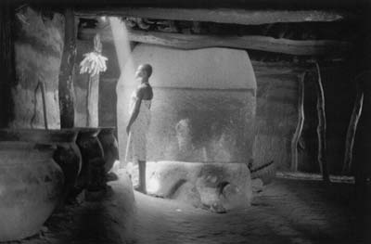
Francoise Huguier

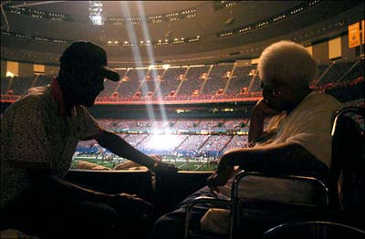
Marko Georgiev

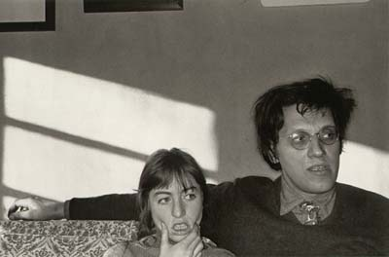
Lee Friedlander

