Light and Shadows in Photographs
In the flat image of a photograph, light and shadows can have as much visual weight as any object in the composition. Additionally, there are many different qualities of light.

SHADOWS

Shadows can have visual weight and become objects.
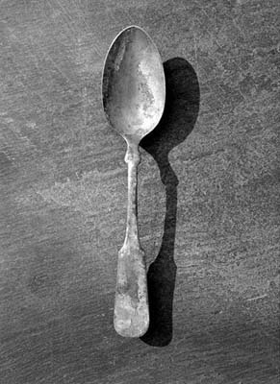
Bob Carlos Clarke

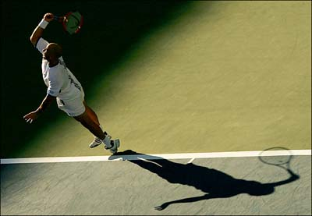
Clive Brunskill

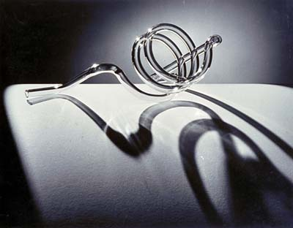
Lazlo Maholy-Nagy

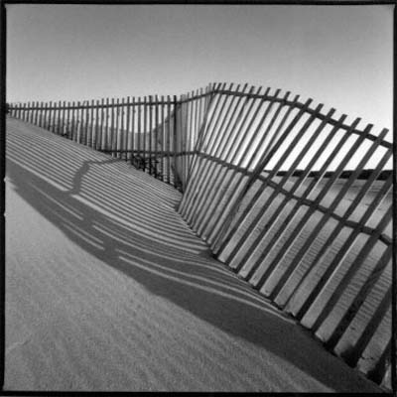
Mel Sewell
Shadows can reference objects outside the frame.

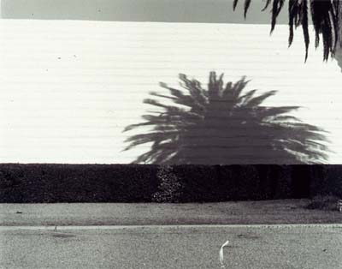
Harold Jones

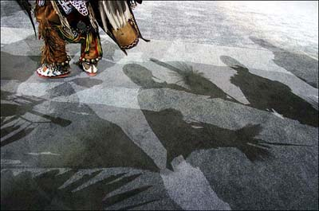
Jamie Rose

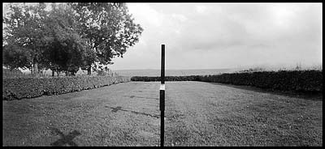
Jane Alden Stevens

