BACKLIGHTING
Light behind objects turns them into Silhouettes.

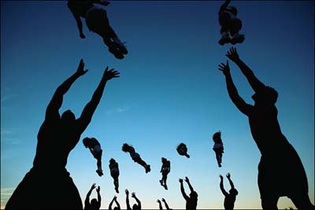
Joachin Ladefoged

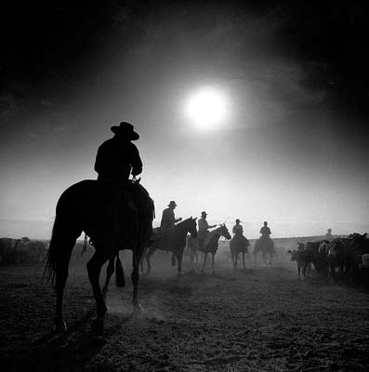
Adam Jahiel

